Byron, Neil, Dr (from Linked In and Wentworth Group website)

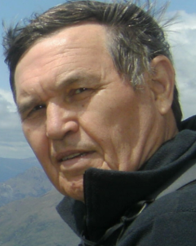

Bachelor of Science (Honours), Forestry ANU 1969-71. Master of Arts (Economics) (Brit. Col.). Doctor of Philosophy (PhD), Resource and Environmental Economics The University of British Columbia / UBC 1973 – 1976. Graduate Aust Institute of Company Directors (Canberra)

The Australian National University 1969 – 1971. Economist BAE Canberra 1978 – 1980. Senior Lecturer ANU Forestry School 1985 – 1991. Assistant Director General CIFOR 1993 – 1998. Commissioner Productivity Commission 1998 –2010. Director Earthwatch Institute Australia 2010 – . Consultant National Water Commission 2010 – 2011. Socio-economics Steering committee Murray Darling Basin Authority 2011.
Adjunct Professor, ANU’s Crawford School of Economics & Government and Fenner School of Environment & Society; Visiting Fellow, University of Melbourne; and Wolfson College, Oxford University. Director, Tiaki Forestry Company, New Zealand. Member, Independent Science Panel for Great Barrier Reef. Member Agricultural & Resource Economics Society.

Previously
Chairman, Trust for Nature Foundation. Member, IUCN’s World Commission on Protected Areas. Assistant Director General, Center for International Forestry Research (CIFOR) Indonesia. Director of Graduate Studies in Environment and Development, Australian National University, Canberra. Chief UN Technical Adviser, Bangladesh Ministry of Finance and Planning, Dhaka. Member Wentworth Group of Concerned Scientists.

